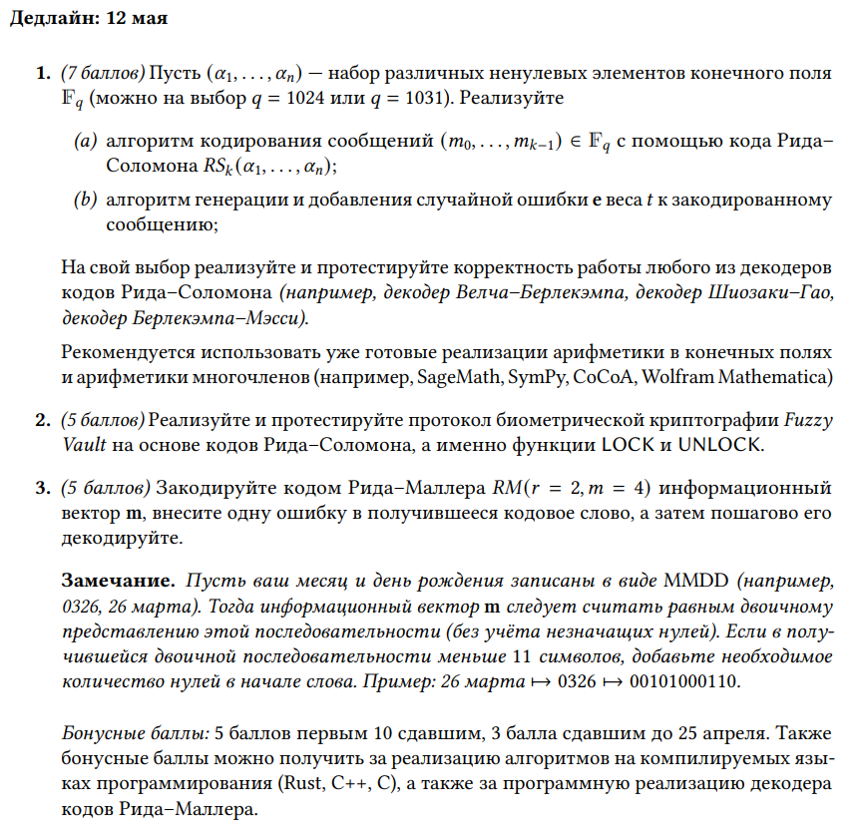

**Индивидуальное задание 2**

**Номер 1**

python  
from sympy import *  
from random import sample  
  
# Parameters  
q = 1031 # Field size  
k = 5 # Message length  
t = 2 # Error correction capability  
  
# Choose n  
n = k + 2*t  
  
# Choose alpha  
alpha = sample(range(1, q), n)  
  
# Message as a polynomial  
m = [1, 2, 3, 4, 5]  
f = Poly(m[::-1], x)  
  
# Generator polynomial  
g = prod([x - alpha[i] for i in range(n)])  
  
# Encode message  
r = (f * x**(2*t)) % g  
encoded = r.nth_list(n-1, 0)[::-1] # Reverse coefficients  
  
# Generate error  
e = Poly(0, x)  
indices = sample(range(n), t)  
for i in indices:  
e += Poly(sample(range(1, q), 1)[0], x)**(i+1)  
r_with_error = (r + e) % g  
  
# Decode  
decoded = r_with_error.nth_list(n-1, 0)[::-1] # Reverse coefficients  
errors = [(n-i-1, int(decoded[i])) for i in indices]  
if errors:  
correct = r_with_error + Poly(errors, x)  
decoded = correct.nth_list(n-1, 0)[::-1]  
  
print('Message: ', m)  
print('Encoded: ', encoded)  
print('Errors: ', errors)  
print('Decoded: ', decoded)  
print('Successful:', decoded == encoded)

**Номер 2**

#Sage Math

import random

q = 19

F = PolynomialRing(GF(q), "x")

M = [1, 3, 2]

k = 3

t = 7

tempA = [2, 5, 3, 1, 4, 6, 7]

tempB1 = [4, 2, 3, 5, 9, 1, 7]

tempB2 = [4, 2, 3, 5, 9, 10, 1]

tempB3 = [4, 2, 3, 5, 9, 10, 11]

def p_x(M, el):

res = 0

for i in range(0, len(M)):

res += M[i] * el ** i

return F(res)

def Lock(A, M):

Vault = {}

for i in range(0, q):

if i in A:

Vault[i] = p_x(M, i)

else:

y = random.randrange(0, q)

yi = p_x(M, i)

while y == yi:

y = random.randrange(0, q)

Vault[i] = y

return Vault

def Unlock(B, Vault):

V = {}

for i in range(len(B)):

if B[i] in Vault.keys():

V[B[i]] = Vault[B[i]]

if len(V) < (t+k)/2:

return "Unsuccessful!"

res = RSDecode(V)

return res

def RSDecode(V):

n = len(V)

A = list(V.keys())

B = list(V.values())

matr = []

for i in range(0, n):

line = []

line.append(B[i])

line.append(B[i]*A[i])

line.append(-1)

for j in range(1, n-2):

line.append(-A[i]**j)

matr.append(line)

AA = Matrix(GF(q), matr)

vec = []

for i in range(0, n):

vec.append(-B[i]*A[i]**2)

BB = vector(GF(q), vec)

#display(AA)

#display(BB)

res = AA.solve_right(BB)

E = []

for i in range(0, math.floor((n-k)/2)):

E.append(res[i])

E.append(1)

EE = F(E)

Q = []

for i in range(math.floor((n-k)/2), n):

Q.append(res[i])

QQ = F(Q)

qq, rr = QQ.quo_rem(EE)

return rr

v = Lock(tempA, M)

res = Unlock(tempB1, v)

if res != 0:

display('Unsuccessful!')

else:

display('Successful!')

**Номер 3**

